**Lab Session 4: DNS and VLAN**

**PART 1: STUDY OF DNS SERVER**

**Q 7.4**

Configure the below topology to setup DNS server. R1 will use R2 as DNS server to make DNS resolutions.

First, let’s begin with R1. We will setup hostname and IP related information.

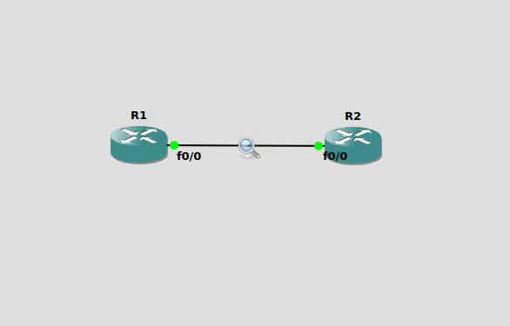

**R1 IP configurations:**

***#Enable***

***#configure terminal***

***#hostname R1***

***#interface e0/0***

***#ip address 10.10.10.1 255.255.255.0***

***#no shut***

***#do wr***

***#end***

**R2 IP and Hostname Configurations:**

***#enable***

***#config t***

***#hostname R2***

***#int e0/0***

***#ip address 10.10.10.2 255.255.255.0***

***#no shut***

***#do wr***

***#end***

**Setting up R2 as DNS Server**

***#config t***

***#ip dns server***

***#ip host loopback.R2.com 2.2.2.2***

We mapped loopback.R2.com to ip address 2.2.2.2. Currently, we don’t have 2.2.2.2, we could create loopback interface on R2 and assign ip 2.2.2.2.

***#interface loopback 1***

***#ip address 2.2.2.2 255.255.255.255***

***#end***

Let us verify that loop-back interface we just created is working. This will show us that the host name correctly setup locally on R2.

***#ping loopback.R2.com***

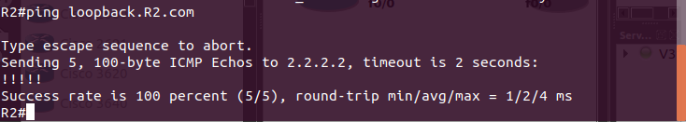

Now it’s time to setup R1 to resolve hostnames using R2.On R1 type:

***#config terminal***

***#ip domain lookup***

***#ip name-server 10.10.10.2***

Set R1 to use R2 as default gateway to get to loopback interface on R2. So that after R1

**resolve loopback.R2.com**, it can reach 2.2.2.2 through its default route (R2).

on R1 type:

***#config t***

***#ip route 0.0.0.0 0.0.0.0 10.10.10.2***

***#end***

This tells our router that to get to any network not in its routing table, it is next hop is 10.10.10.2 which is our router R2.

Now on R1, do a ping to loopback.R2.com and you should get a success message.

***#ping loopback.R2.com repeat 3***

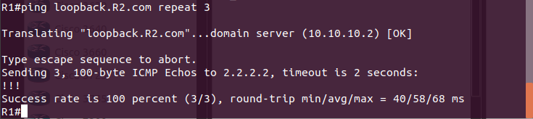

If you captured the traffic, you will see DNS query and Answer as shown in Wireshark capture screen shot below.

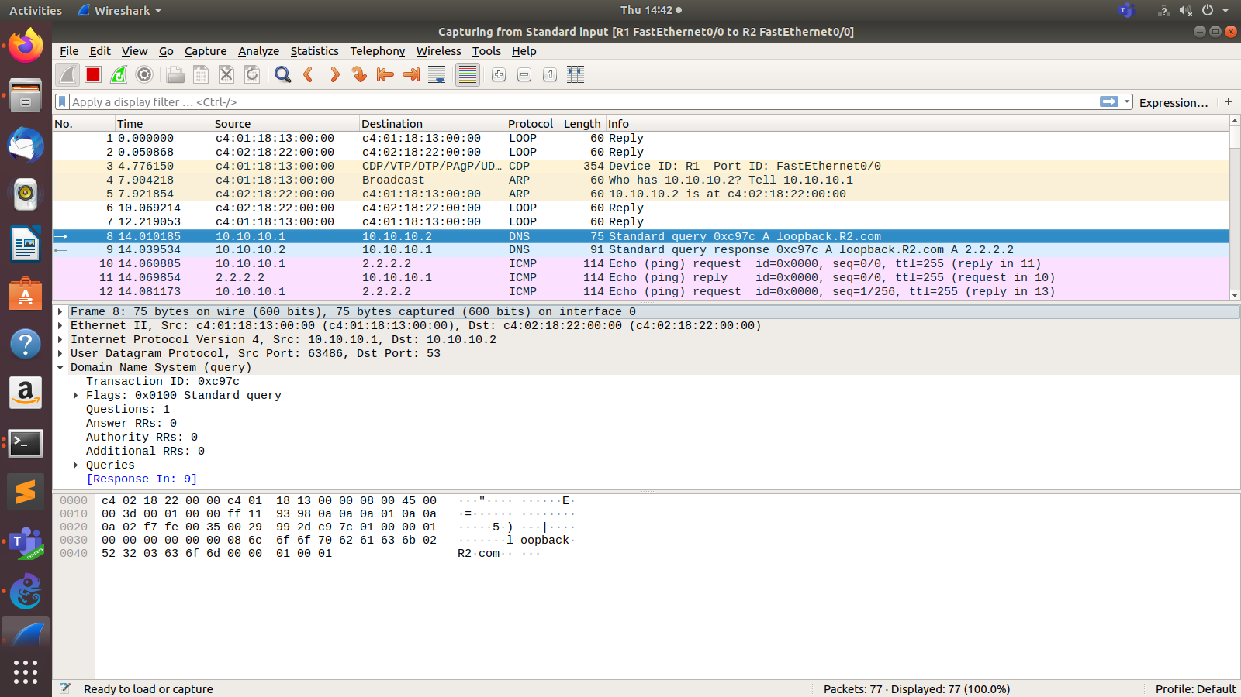

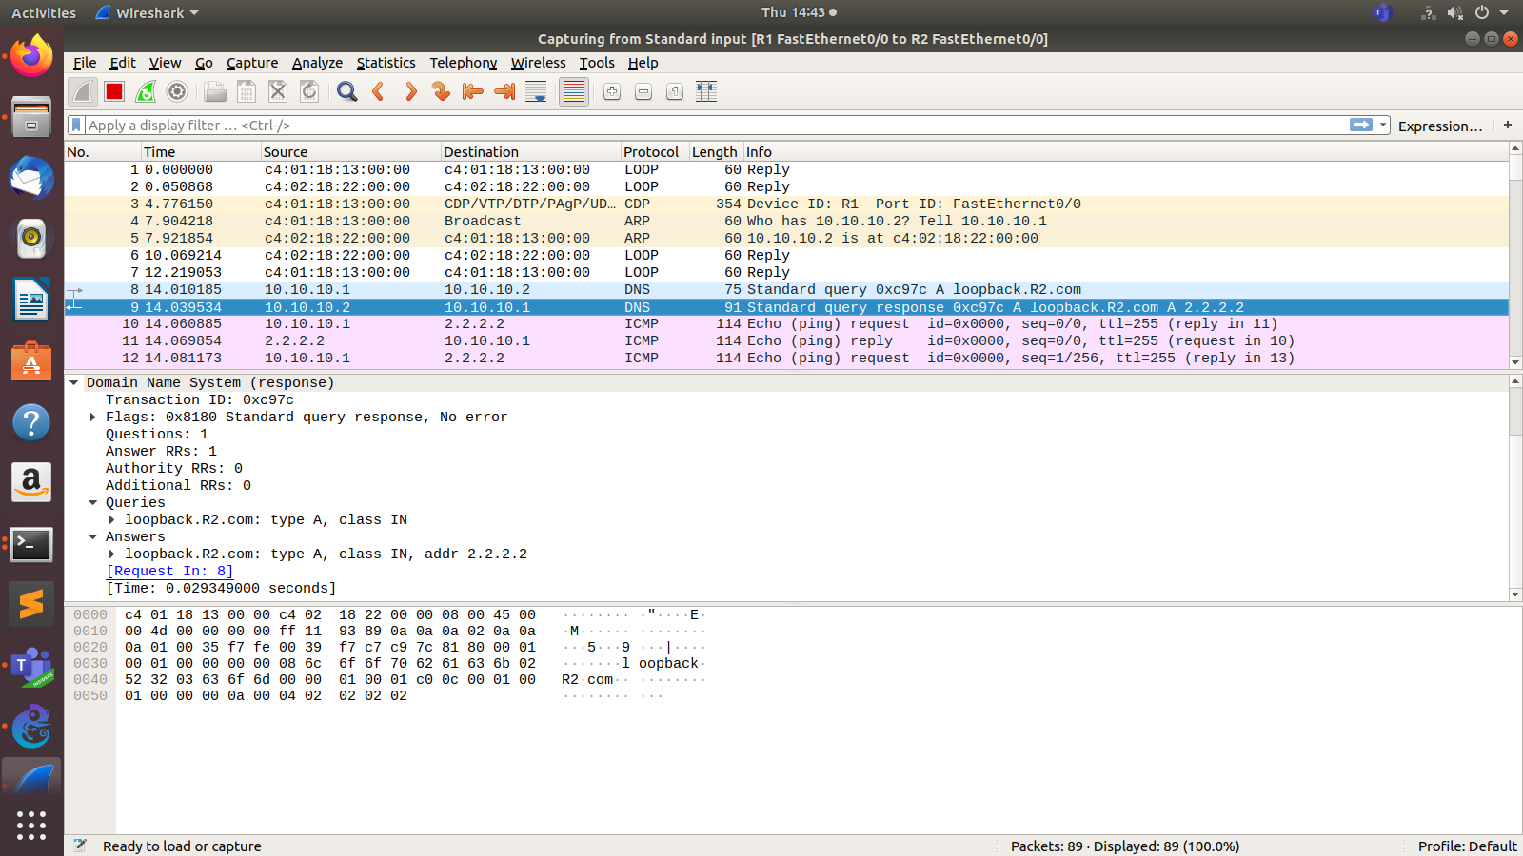

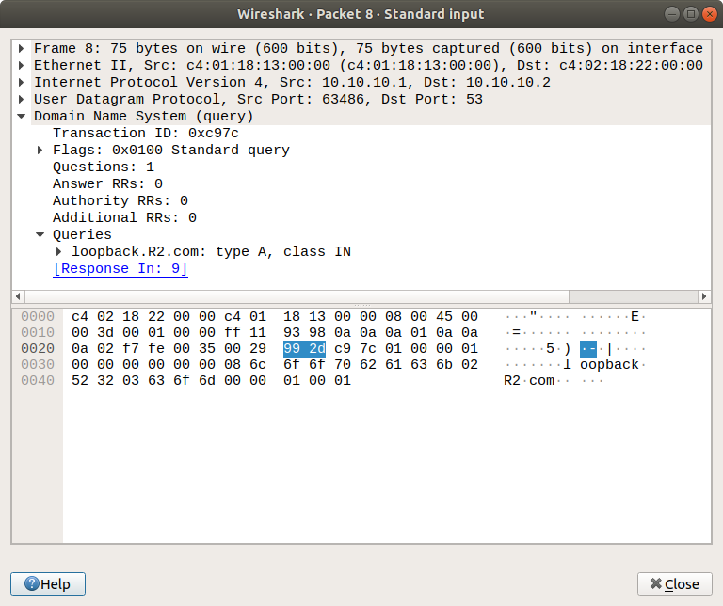

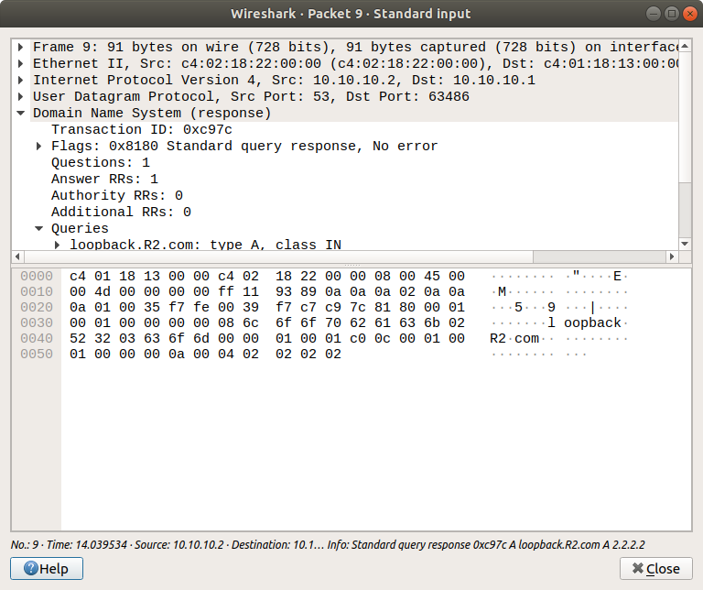

**Q 7.5**

Configure the topology shown below DNS Server and DNS Client. Test the setup. Analyse the Interaction.

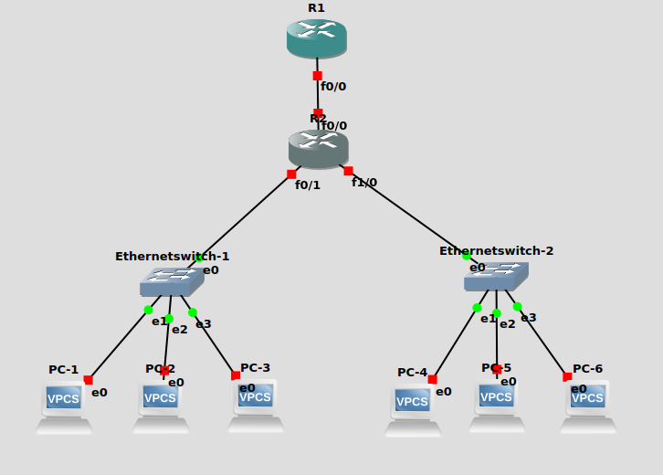

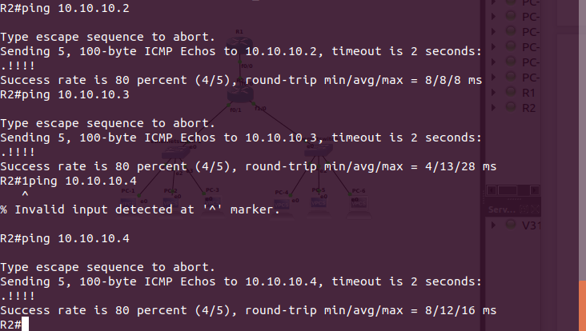

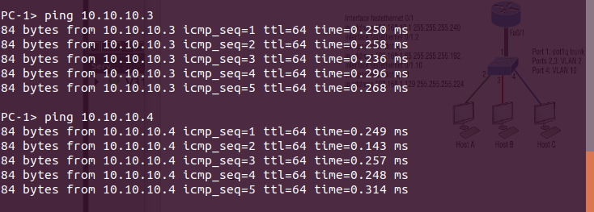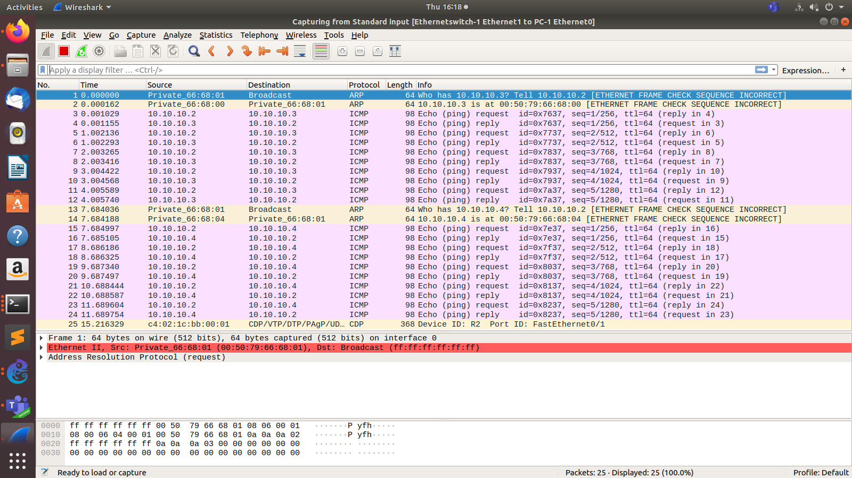

**PART 2: STUDY OF VLAN**

**Q 8.1**

Configure following inter-VLAN example in GNS3 and verify the working using Wireshark tool.

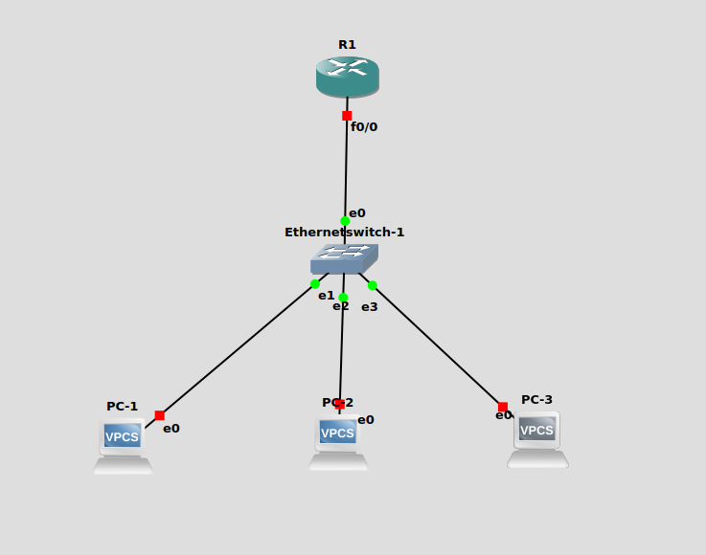

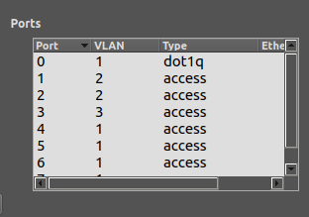

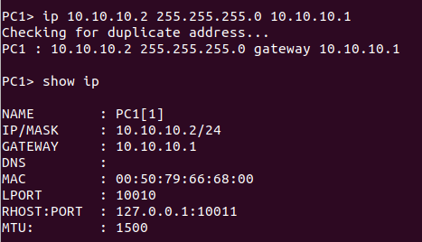

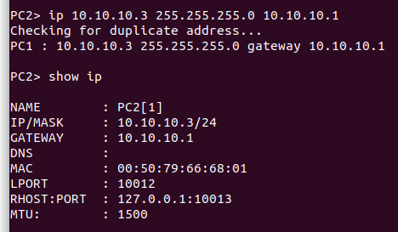

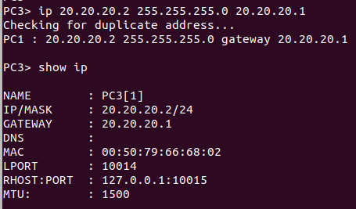

**Pinging PC2 from PC1(SAME VLAN)**

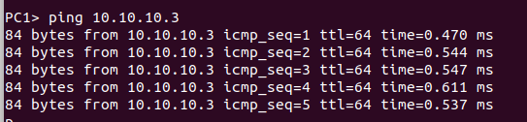

**Pinging PC3 from PC1 (different VLAN)**



**Configuring the Router.**

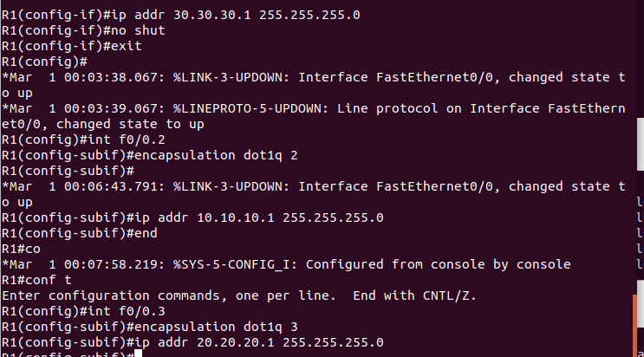

**Now pinging PC3 from PC1 again.**

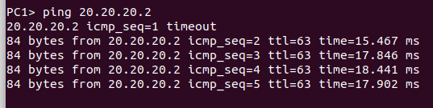

**WIRESHARK OUTPUT**

**PACKET details for the request message (from VLAN 2)**

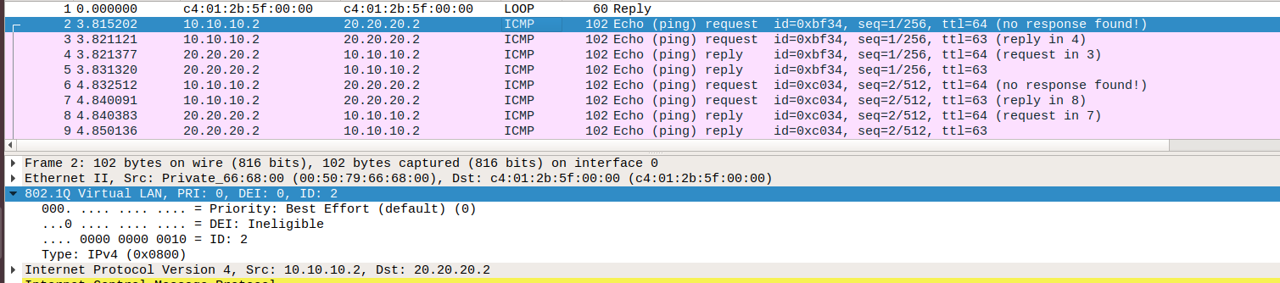

**Packet details for the reply message (from VLAN 3)**

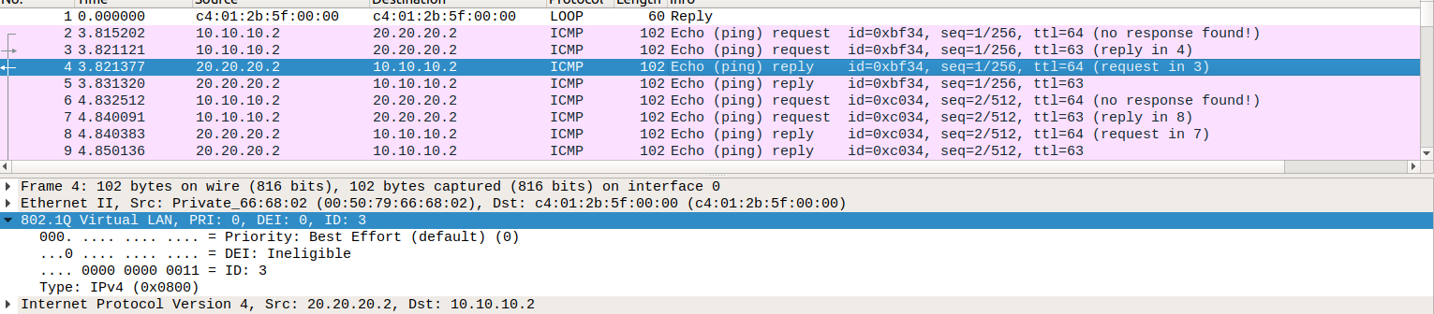

**Q 8.2** Configure following inter-VLAN example in GNS3 and verify the working using Wireshark tool.

